The State of Michigan
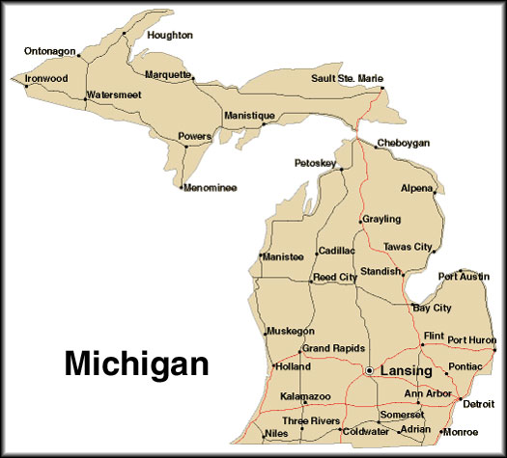 | - This is what the state of Michigan looks like.  - Michigan is the only mainland state with two large parts.  - Michigan is surrounded by four of the five Great Lakes.
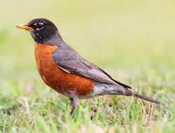 | - The state Bird of Michigan is the Robin.  - Robins are migratory.  www.wikipedia.org
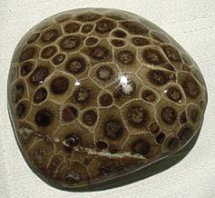 | - The state stone of Michigan is the Petoskey Stone.  - Petoskey stones are fragments of an ancient coral reef.  www.davesdowntoearthrockshop.com
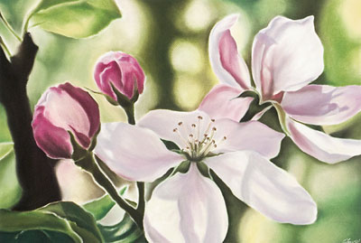 | - The State Flower of Michigan is the Apple Blossom.  - There are at least 9,999,999,999 Apple Blossoms in the United States ;-)  www.appleblossom.org

