Setting up WebQuest Website

Save the web pages of the WebQuest Project in the same folder as your ePortfolio files.

Step 1: Build a Template

- Name it Template.html  - Go to Insert > Table  - Choose a width, e.g. 80% (of the whole screen)  - 1 row  - 2 columns  - 80%  - 0 border  - Click OK | 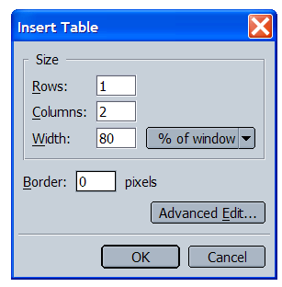

Step 2: Tailor the table in the Template to your needs - work on width and color of a specific cell.

- Put the cursor in the cell you want to work on.  - Right Click > Table Cell Properties and you will see a pop-up window like this.  - Choose a width, e.g. 20% (of the whole table)  - Choose a background color by clicking the little box next to Background Color and the color palate window pops up  - Choose a color  - Click OK. Now you should have a table of 1 row, 2 columns, with the left-hand cell taking up to 20% of the whole table. | 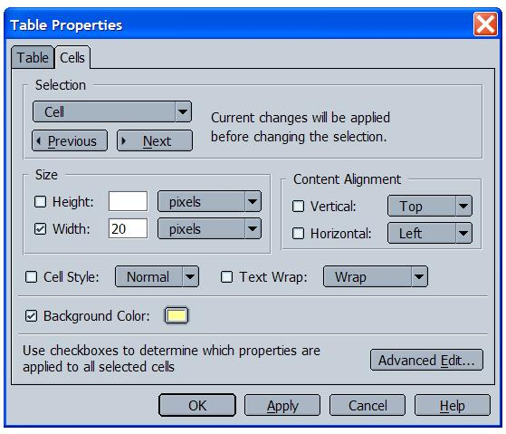

Step 3: Add the 6 components in the Navigation Bar:
- Introduction
- Process
- Task
- Evaluation
- Conclusion
- Teacher Page

Step 4: Create 6 new empty pages.

Step 5: Go back to Template, interlink all the 6 pages so the links in the navigation bar all works.

Step 6: Open Template and save it as the following pages. Add a title to each page as you go. Be sure to go to Format > Page Title and Properties and write the correct title of the page. Close the windows as you go and open the template for the next page – go in order.

- Introduction
- Process
- Task
- Evaluation
- Conclusion
- Teacher Page

Now you should have the framework of the WebQuest website set up. The next step is to work on the contents of your WebQuest.

* * * * * * * * * * * *
Step 7: Your new group of 4/5 will select one biome from the following list:

Deep Ocean Biome Desert Biome Arctic Biome Mountain Biome

Savannah Biome Coral Reef Biome Rainforest Biome Tundra Biome

If you would like to select a different science-relate topic you may, be sure to check it with Dr. Susan Stratton before proceeding.

Step 8: Some possible tasks that work well with biomes that you may want to consider are:
- Identify natural resources found in this biome and how we use them.
- Identify important and interesting plants found in this biome.
- Identify important and interesting animals found in this biome.
- Identify what human activities are doing to endanger the particular biome.

These are possible ways to approach the development of your WebQuest, but develop your own if you have an idea in mind or see a good example to imitate.

Step 9: Search and discover what a biome is in general, and identifying the specific characteristics of the particular biome your group has selected. Please bookmark or bring links to at least 6 sources that are interesting and not too difficult for 3rd and 4th grade students to understand. You should also identify the specific standards and key ideas that correspond to your WebQuest. You will be writing out the MST Standard(s) and Key Ideas.

Step 10: Review the criteria for Project #3 WebQuest Project (http://web.cortland.edu/shis/314/project3.htm), and examine several examples of WebQuests that are provided, after careful consideration, decide upon and complete the text for each of the following sections of your WebQuest:

Introduction
___________________________________________________________________________________________________________________________________________________________________________________________________________________________________________________________________________________________________________________________________________________________________________________________________________________________________________________________________________________________________

Process
___________________________________________________________________________________________________________________________________________________________________________________________________________________________________________________________________________________________________________________________________________________________________________________________________________________________________________________________________________________________________

Task
___________________________________________________________________________________________________________________________________________________________________________________________________________________________________________________________________________________________________________________________________________________________________________________________________________________________________________________________________________________________________

Evaluation
___________________________________________________________________________________________________________________________________________________________________________________________________________________________________________________________________________________________________________________________________________________________________________________________________________________________________________________________________________________________________

Conclusion
___________________________________________________________________________________________________________________________________________________________________________________________________________________________________________________________________________________________________________________________________________________________________________________________________________________________________________________________________________________________________

Teacher Page
(To make things easier, you can choose to do only one page for teacher page and the page will include objectives, standards link, grade level, teacher background information, credits, and resources, etc.)
________________________________________________________________________________________________________________________________________________________________________________________________________________________________________________________________________________________________________________________________________________________________________________________________________________________________________________________________________________________________________________________

