Netscape Composer: Working with Tables

Why tables?
Tables on the Web can be divided into two categories: data display and page layout. Although the method for making both kinds of tables is the same, it helps to know what kind of table you want before you begin building it.
- Tables are commonly used to display or organize data. Alignment of text and images is a common issue in web page layout. If you have more than one line of text you want to line up with an image, you will find that everything goes out of whack. So, to solve most alignment problems, you will want to use tables. Data tables act as discrete elements of a Web page, much like tables inserted into word processing programs.
- Tables can also be used to direct page layout. Tables are ubiquitously used in page layout. This will be our focus.

Insert a table
- Position the cursor where you want the table to appear and click once.
- In the menu bar, choose Insert > Table or choose the table button on the toolbar. This will bring up the 'Insert Table' dialog box. The 'Insert Table' dialog box lets you tailor the table to your specific needs:
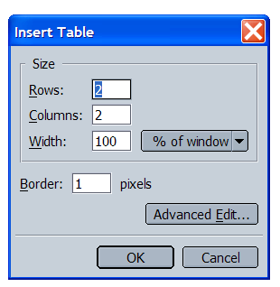

Rows: Specify the number of rows you would like your table to have. You can always add more rows easily.
Columns: Specify the number of columns you would like your table to have.
Width and Height Tables will automatically stretch to accommodate whatever you put in them (graphics, text, etc.) If you want your table to have a specific width, be sure to check the box and specify a dimension in the text box.
- Width in percent means percent of the page, regardless of what size the page is on any viewer's screen. 80% is fine.
- Width in pixels is absolute: the table will be, say, 400 pixels wide, no matter how wide the viewer's browser window.
Borders are what outline your table. All table boarders are defined in pixels. If you do not want a border around your table, change the border line width to zero. If you want a wider border, put in a larger number than 1.
Border = 0
Border = 1

Border = 2

Border = 3

Border = 4

Border vs. no border
If you have chosen to use a border with your table, the border will appear in Composer exactly as it will appear in Navigator. If, however, you have chosen not to use a border, you will still see a double dotted line around your table in Composer to delineate the table area. This will NOT be visible in Navigator. It is simply a visually defined work area.

Changing table properties

After a table is inserted, You can at any time change the basic characteristics of your table. Place your cursor within the table, click the RIGHT mouse button, and the menu below will appear.

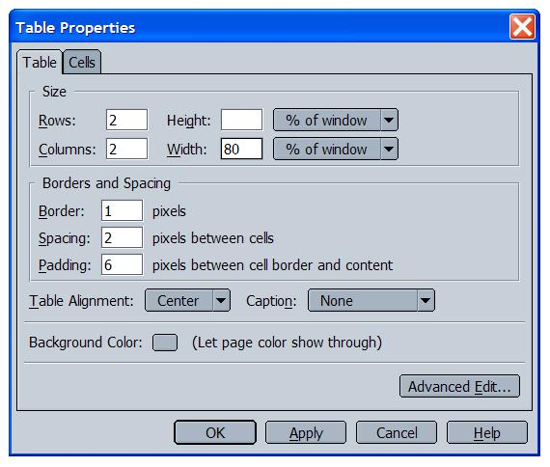
The Rows, Columns, Width and Height, and Border are the same as in the popping-up window when you first insert the table. You can always change them if necessary. Other commands:

Cell Spacing: This is the amount of space (in pixels) to place between the table cells. 3 is fine.

Cell Spacing | = | 0

Cell Spacing | = | 5

Cell Spacing | = | 10

Cell Spacing | = | 20
Cell Padding: This is the amount of space (in pixels) to place between the gridlines of the table (invisible or visible) and the contents of its cells. 3 is fine.

Alignment of a table
Alignment The table alignment choices in the box above refer to where the table will appear on the page. You can have it flush left (right next to the left margin), flush right (next to the right margin) or centered.

Changing background or colors of a table
Background Color You can select a color for the background of your table by clicking on the blank button next to the "Backgroud Color" choice in the box above. The same color palette you're used to will pop up: choose one of these colors by clicking on it, or click on "other" to make the full color palette available.

Moving around in a table
Let's assume we have inserted a table with one row, two columns, no border, 30% of page, centered. It would look like this:
To move from the left cell to the right cell, press TAB. To move back from the right to the left, press SHIFT + TAB.
To add another row, place your cursor at the end of the last cell (the one on the right) and press TAB. A new row will automatically appear.
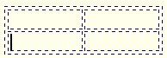

What can you put in the cells of a table?
You can put text or images in the cell of a table. To insert text, click your cursor in the cell where you want the text to appear. Begin typing. If you hit "Enter," the cell will automatically expand to accommodate the new line within that cell.
To insert an image in a cell, click your cursor in the cell where you want the image to appear. Then click on the image icon in the tool menu bar, choose the image file you want and click "OK." The image will now appear in the cell. You can make it a link (click on the image to select it, then click on the link icon in the tool menu bar, select the file or page you want to link to, click OK to close the dialogue box) or align it within the cell (click on the image to select it, then click on the alignment icon and choose left, right or center).

Adding or deleting parts of a table
To add a row, place your cursor in the last cell of the table (lower right-hand corner) and press TAB.
To add a column, place your cursor in the cell TO THE LEFT of where you want the new column to appear. Click the RIGHT mouse button and the following menu will appear:
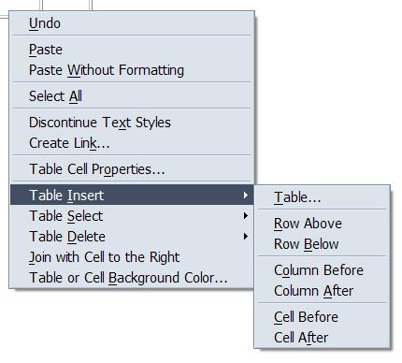 | Click on "Insert" and you will have seven choices as you can see from the menu.  Select "Column Before" and a new column will appear before the cell where your cursor is right now.

To delete all or part of a table, place your cursor inside the table, click the RIGHT mouse button and the menu below will appear.

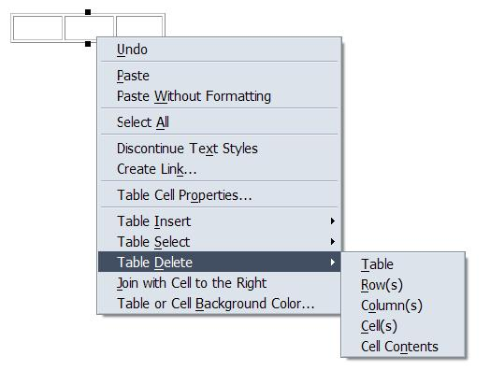 | This time click on "Table Delete" and you will have five choices as you can see from the menu.  You can delete the entire table, the row you are in, the column you are in or the cell you are in.

Acknowledgement: This tutorial is adapted from Pat Pecoy’s Netscape Tutorial at http://facweb.furman.edu/~pecoy/mfl195/composer/tables.htm and from Catalyst’s tutorial: http://catalyst.washington.edu/how-to/composer/table.htm and other resources.

